**203CR SUMMATIVE REPORT TEMPLATE**

Edgar Podvezko

8992570

OneDrive Link: https://livecoventryac-my.sharepoint.com/:f:/r/personal/podvezke_uni_coventry_ac_uk/Documents/203CW?csf=1&e=yDCrkJ

ABSTRACT

In this report I have described the procedure of development of a mid-fi prototype of an app, which would improve users’ shopping experience and might even change the whole concept of shopping lists. Within the process I have created a mid-fi prototype of a shopping app, tested it, after, based on the users feedback I have improved my second prototype and tested it on the same users to compare their experience and understand if there are more improvements can be done.

INTRODUCTION

As a smartphone user, who wants to use apps to make things in daily life easier, I look for an apps for a specific area I am interested in (organizers, programming etc.). In the apps market I find a category I am currently interested in, browse for apps, download them, test them, compare my experience by analysing the reviews and decide whether I keep it or continue searching for something better.

At some moment I thought of an app, that will make my grocery shopping life easier, as I was facing a few requests in the app regarding that.

* If I run out of something at home, or if I think of buying something new, I would like to put it in my shopping list straightaway, without making one global checklist before going on a weekly shopping, in case I forget anything.
* If I go to the shop I have not been, I would like to know in advance, in which aisle I need to find a specific product in order not to waste time looking for a specific product.

At the same moment I have got a concept of how an app should look like, so this time I had a specific criteria’s while searching for an app. After apps research (the results of my research you can see below), I have started developing my prototype.

MARKET RESEARCH

For market research, I will begin from afar. Based on my previous researches, I was finding apps and comparing them, thinking what I like about an app and what I would like to see different. For instance, if I need an app to study the programming language from scratch, after some research, I find “SoloLearn” application, which was developed for absolute beginners in programming and will help me to do that in a quick and efficient way through lessons, challenges and helpful community. After using it and researching for similar apps, almost straightaway I discover “Codemurai”. Unlike SoloLearn, Codemurai does not have wide selection of courses and navigating might be found a bit confusing at first. But it has a feature, which makes it exceptional – visualisation in theory materials. Interestingly enough, both of them achieve the same goal, but different ways (Figure 1).

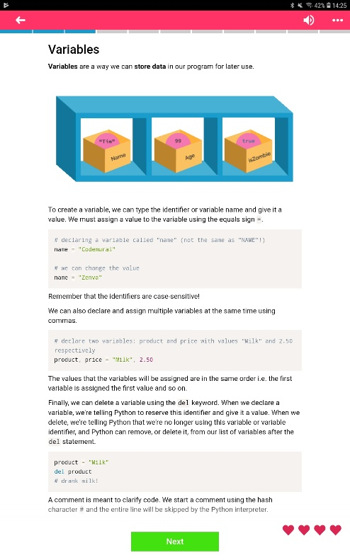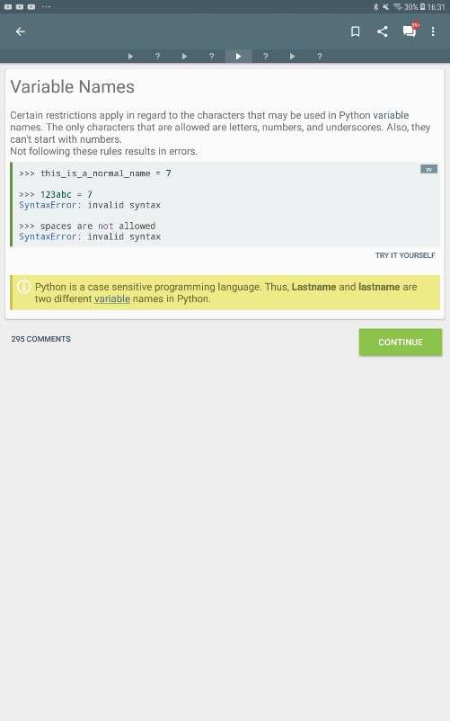

*Figure 1: This is “variables” for Python are explained. If SoloLearn (right) keeps it more professional, Codemurai (Left) makes it more user-friendly. Both of them are achieving the same goal (explaining variables in detail), but there is only one detail, that makes a difference.*

In other case, if I need an app to track my finances, I will find an app “1Money”, with great design, easy-to-use functionality and, mainly, combination of these two serves their purpose perfectly. As can be seen on Figure 2 (left), expenses might be displayed on donut pie chart with additional information on the sides There is also possibility to see an overview of it and transactions recorded by user to analyse for further savings. All that in simple functionality and attractive design makes it an outstanding app which will do the job perfectly. One of the alternatives I would like to show is Expensify (Figure 2, right), which has very different concept, but has the same goal. It works simple by storing receipts as an image and calculating overall. One of the additional things available is to store selected data in the report where sum will be calculated.

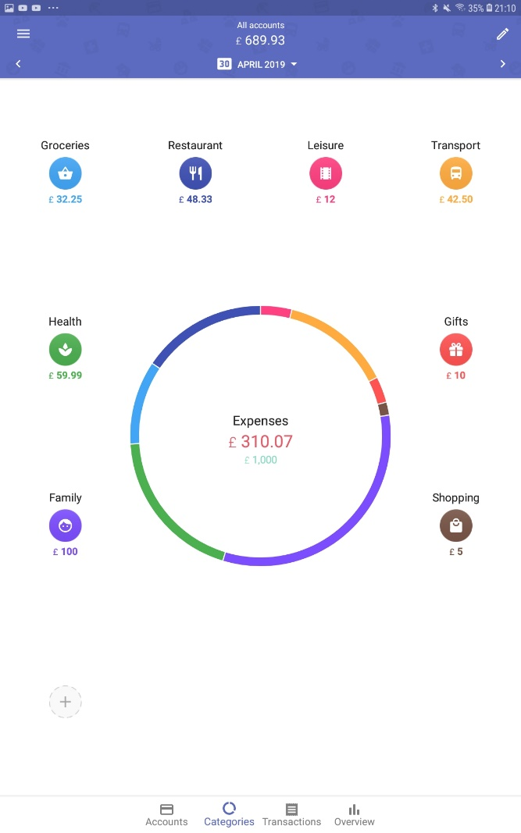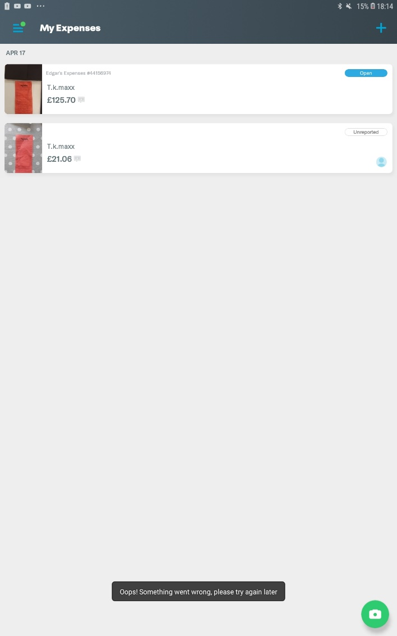

*Figure 2: In 1Money (Left) you manually enter your income and expenses, all of it is displayed on 1 screen with pie chart in the middle, which helps to see, how much you spend on a specific area. Expensify (Right), stores pictures of the receipt, which will let you to analyse later on, how much and on what user had spent money on.*

I know, that I will not be using this Expensify, as I don’t keep receipts, pay with card as much I can, but some other people can and will find it useful, for example, people who owns a small business or people who are preparing for a tax return.

After these examples you might have a better idea, that app store had a lot to offer in most of the areas. The apps might only have small difference in design or have complete different technical part and still serve the same purpose very well.

When it came to the research for shopping list, I have to go to the very basics of it – paper editions. With first known shopping lists being dates 4,000 years old in Ancient Mesopotamia (Waygood, n.d.) they went long way to our days still being popular with shoppers.

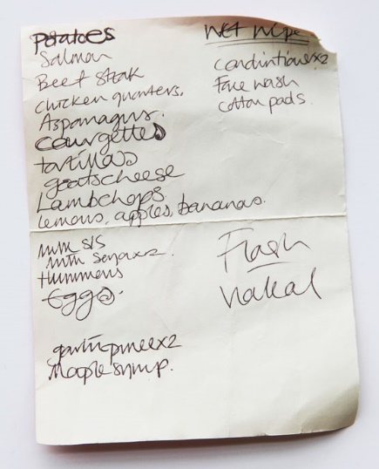 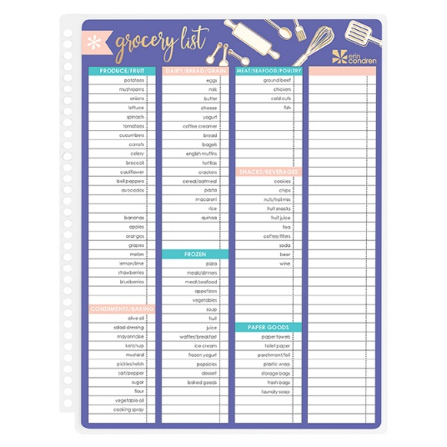

*Figure 3: On the left side you can see paper version of the shopping list, known for a very long time. On the right side you can see, that there are templates available to download and use for shopping lists to be more organized.*

However, these solutions have some drawbacks. Paper shopping lists can be forgotten at home or get lost either at home or in the shop. Another thing I will mention, is that you need to be careful with it and keep it separated from other things, as it might fall off from the pocket or lose it’s original condition.

When I went online, I firstly began looking for an apps developed by big supermarket chains and there is nothing on the market that will allow to have shopping lists. Only thing closest they have to offer is a home delivery. And as not always user would want to pay extra money, they would rather go themselves. And furthermore, it wouldn’t be convenient for user to keep several apps in the phone, one for every shop.

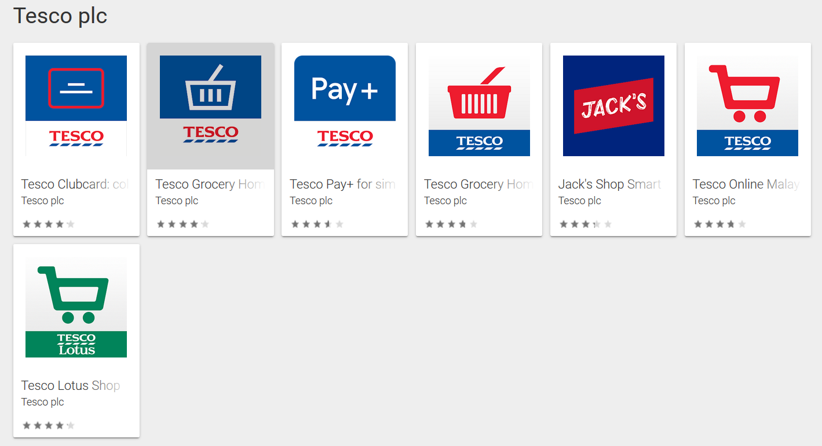

*Figure 4: Similar image can be seen in all the official developer’s pages.*

Next category is very straightforward: shopping lists. There is a lot of apps you can download, and they are not very different one from another as concept in general is too simple: to keep the shopping lists. One of the best shopping lists apps, according to bestproducts (Best Products, n.d.), are “Bring!” and “Out of Milk”.

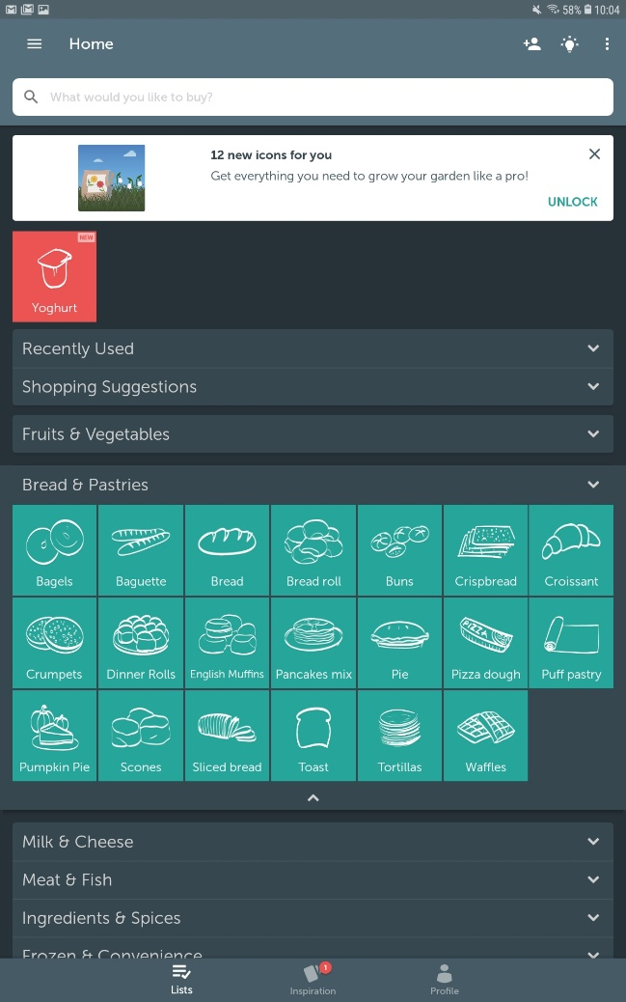 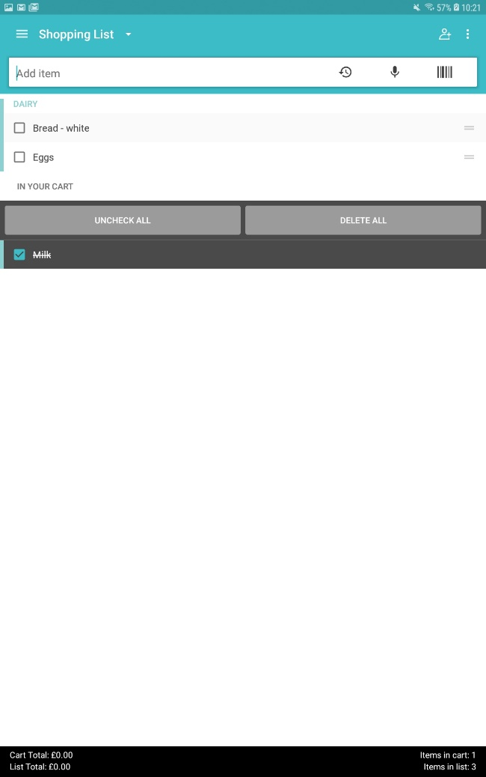

*Figure 5: One of the best apps available on the market for iOS and Android: Bring! (left) and “Out of Milk” (right)*

As expected from the top apps from the category, both of them has basic but efficient design. “Bring!” has everything on 1 screen, ability to see shopping list user created and add to it straightaway. It has all of the categories user needs, and the drawing of every type of product is really eye-catching. “Out of Milk” has way more basic design, but at the same time functionality is way bigger – starting with the lists the lists themselves (create, share, manage etc.). You can also have a To-Do list, pantry list and recipe book, where you can browse for recipes.

METHODOLOGY

Despite having great solutions on the market, I felt like something was missing, something that people in the UK would love to use. When creating my background and working with colours, I was referring to the colour wheel (Smashing Magazine, n.d.), analogous colour scheme to create blue intense background effect provided by PowerPoint and used monochromic scheme, using darker shade of blue for text, except the “About” part, where I used grey as it makes good contrast on the blue background. Functionality is simple, but requires a big database at the same time, for all the shops in the UK with a specific aisle for a specific product. There are 2 sections available for user throughout both of prototypes: map with shops selected from the dropdown menu, which takes user to she supermarket selected, and there user can put products in the shopping list by selecting the quantity by pressing ‘+’ and ‘-‘, and pressing tick to confirm and add product to the shopping lists. At any moment user can access shopping list and delete the product from the list.

For the implementation I have used Microsoft Office PowerPoint, quite powerful tool to not only make presentations, but to create prototypes for both apps and websites, to create both of my prototypes, their interface and functionality. For surveys I have used a template on Onlinesurveys.ac.uk and later converting data from the surveys into the graphs I have used Microsoft Office Excel. And for recording I have used screencast from screencast-o-matic.com

FIRST PROTOTYPE

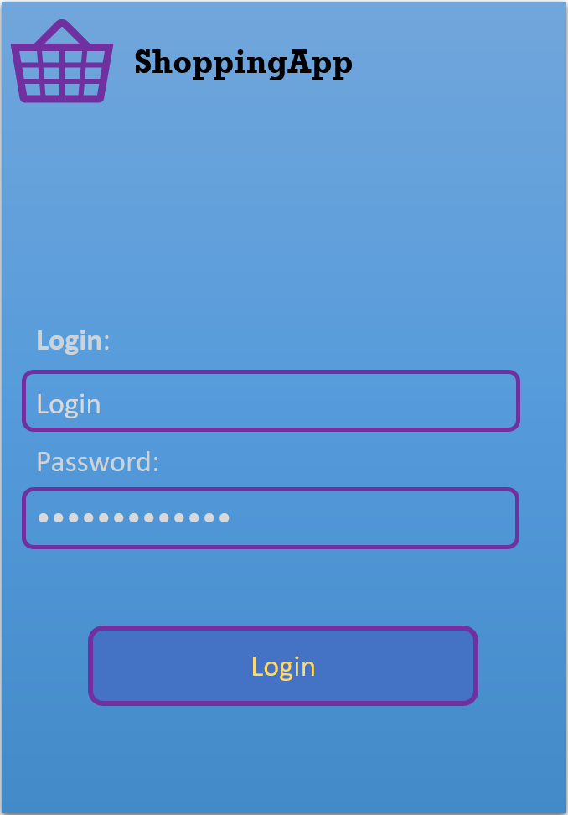 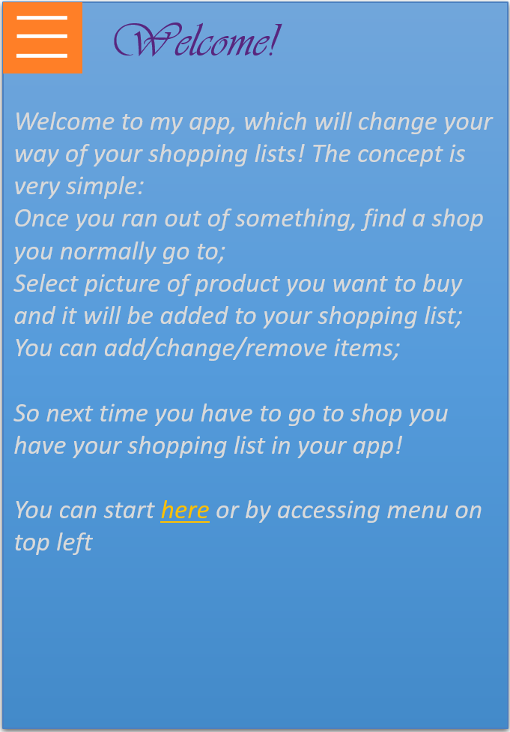

*Figure 6: Login Page, which takes you to the “About” page. Explaining the purpose of an app (spelling mistakes takes place).*

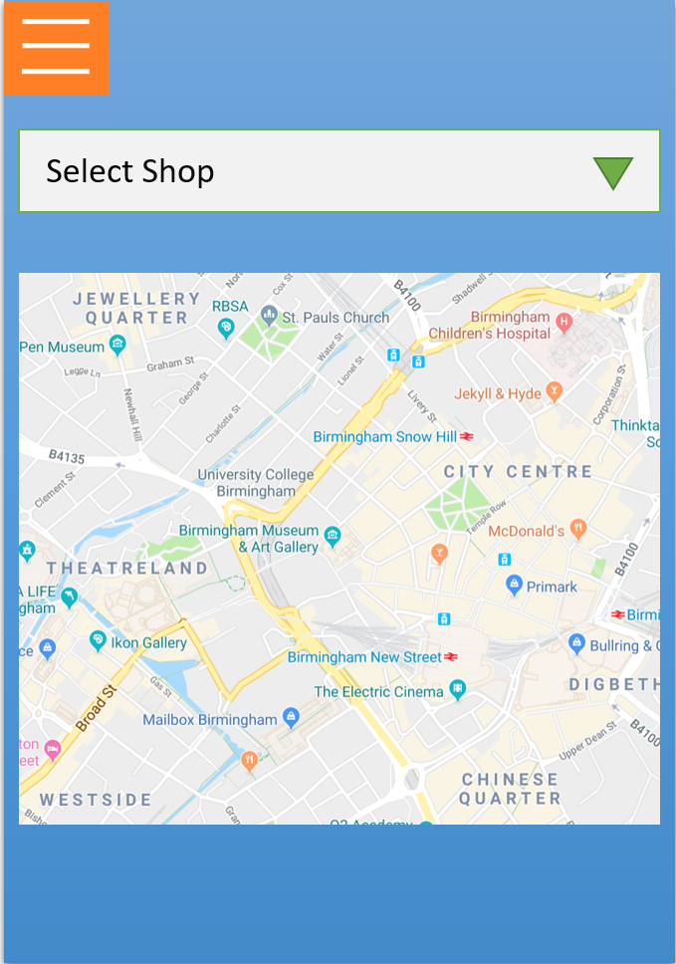 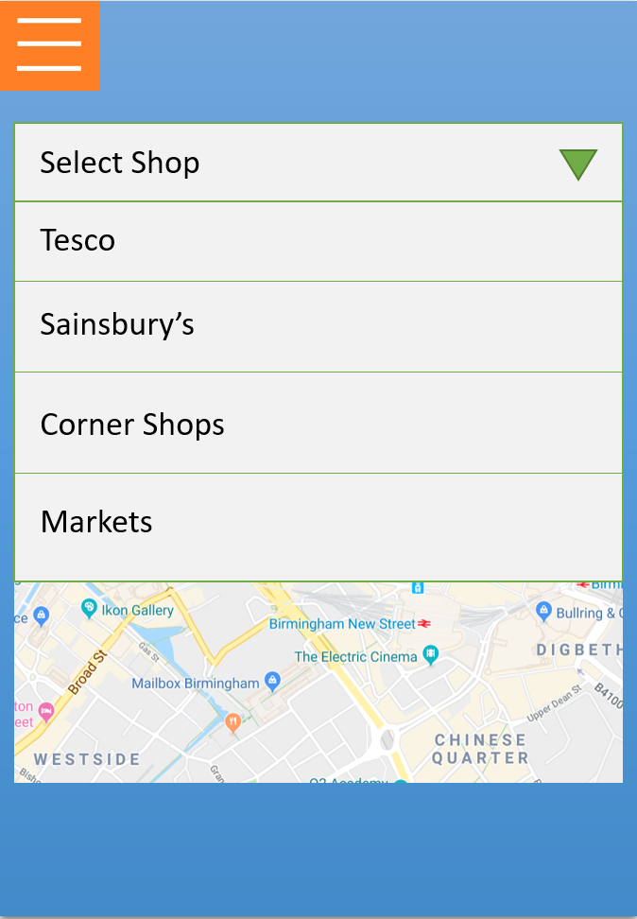

*Figure 7: Map of current user’s location (Birmingham City Centre). On top there is dropdown menu (fully functional), which displays list of the shops available.*

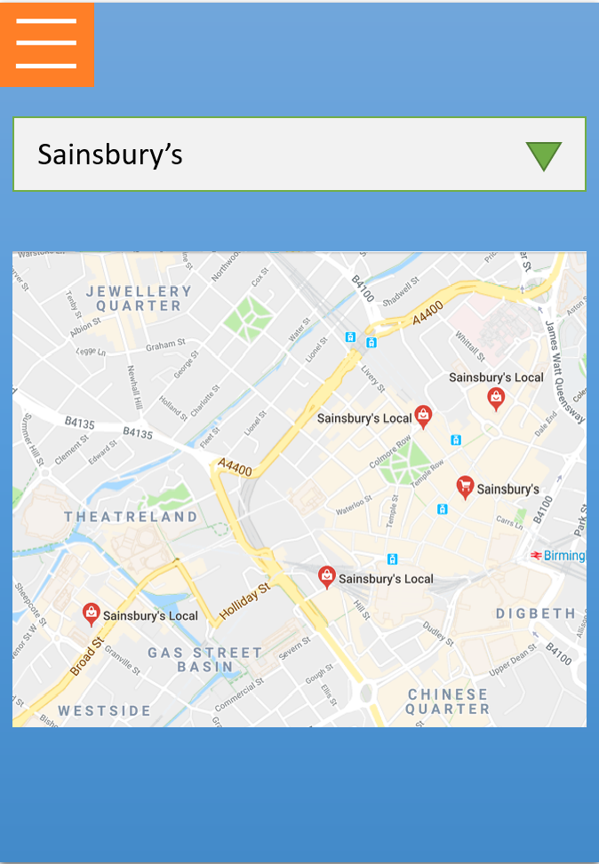 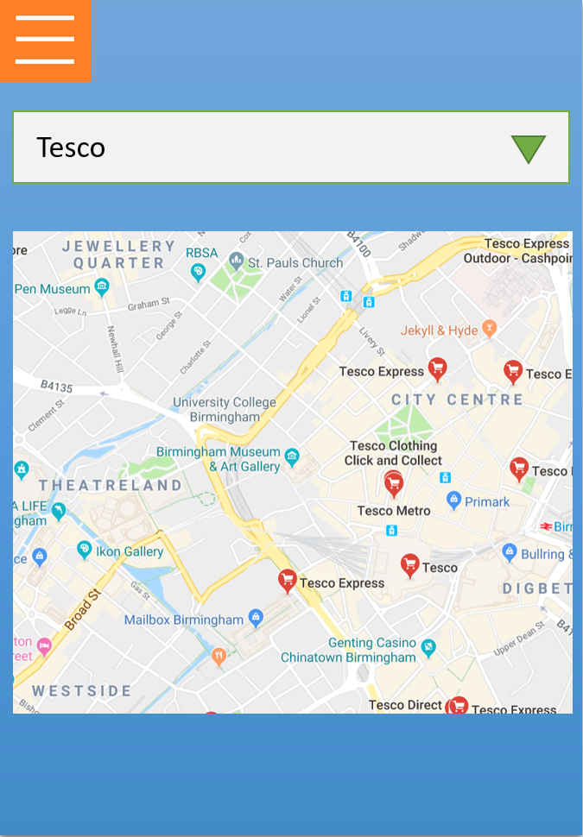

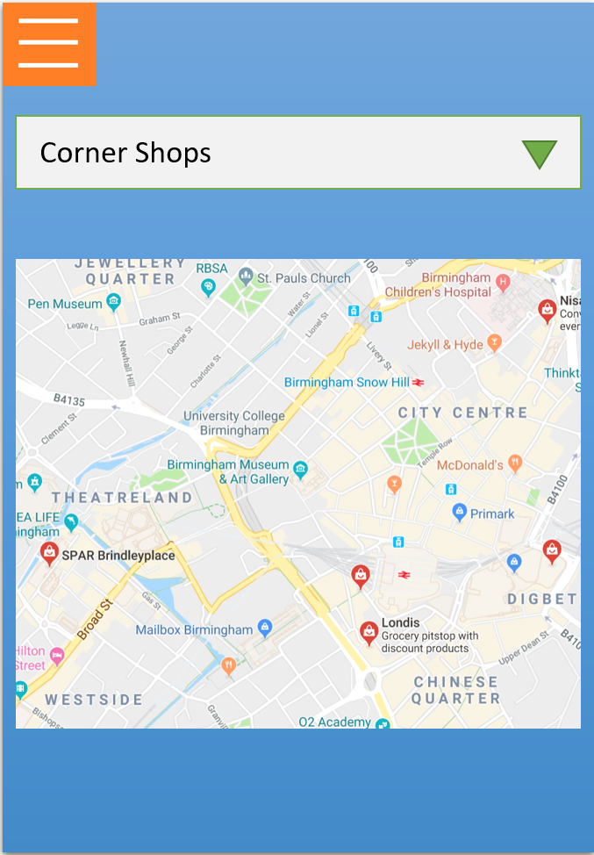 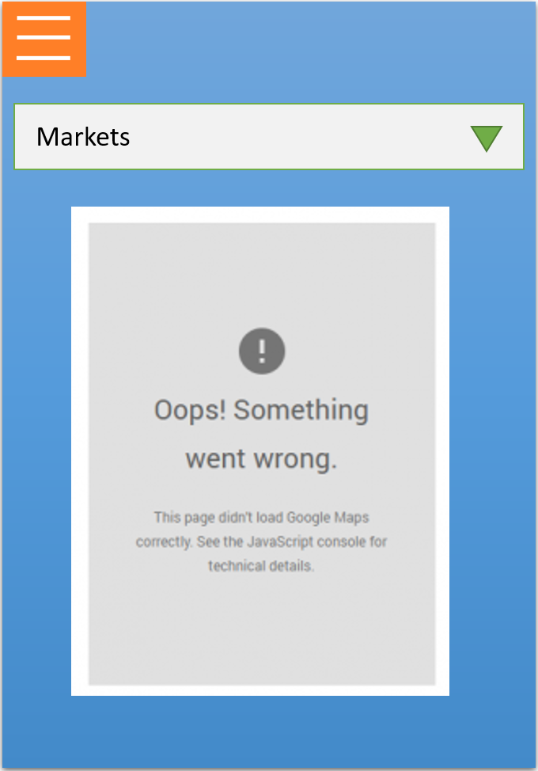

*Figure 8: Map for all of the dropdown sections: Sainsbury’s (all Sainsbury’s Local pins are active), Tesco (only Tesco Metro pin is active), Corner Shops (only SPAR Brindleyplace is active), Market (is not available yet).*

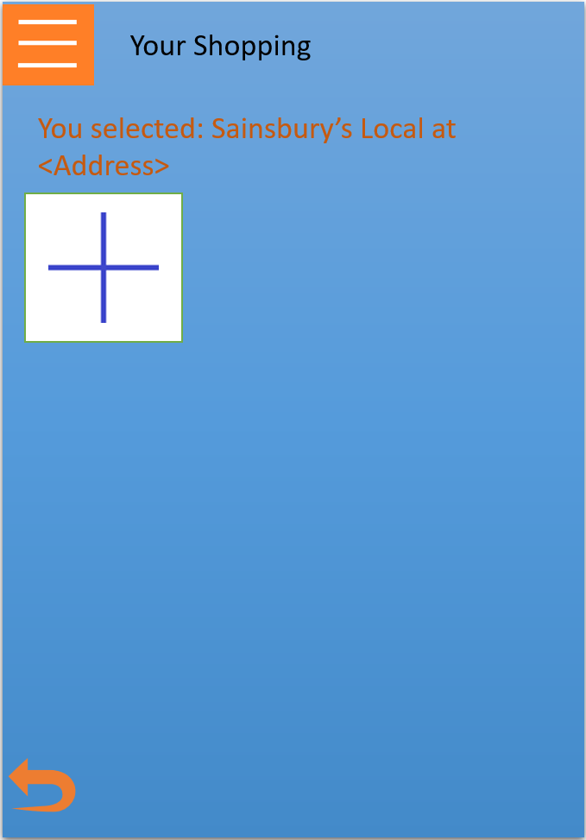 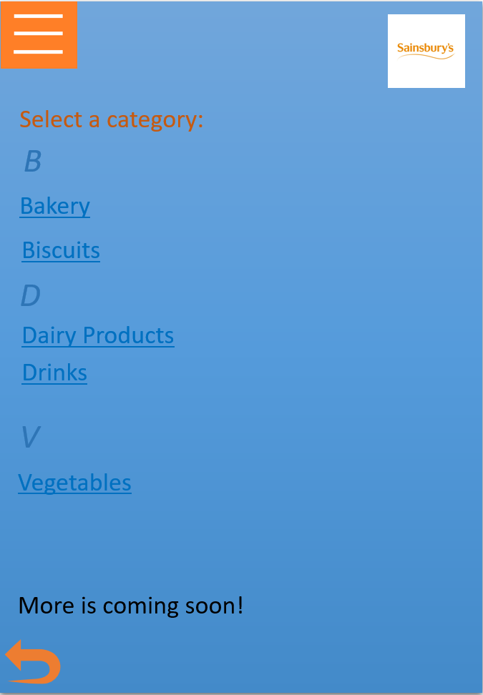

b

a

*Figure 9: After shop displayed it takes you to the page which is supposed to show you shopping list here, not fully functional. Pressing ‘+‘ will take you to the next page, where you will see: logo of the shop (a), categories (in alphabetical order) (b)*

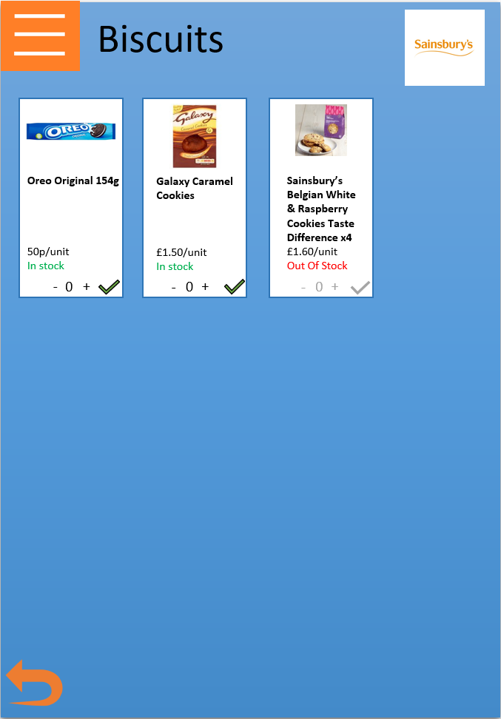 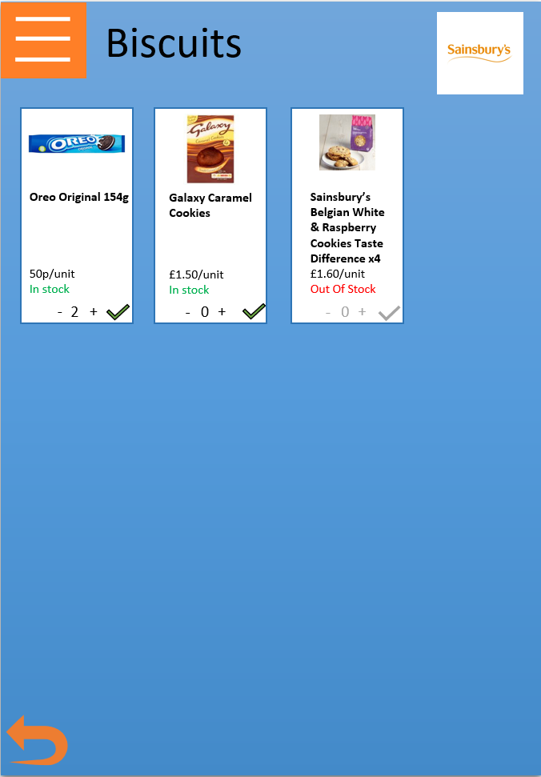

b222

b12

a

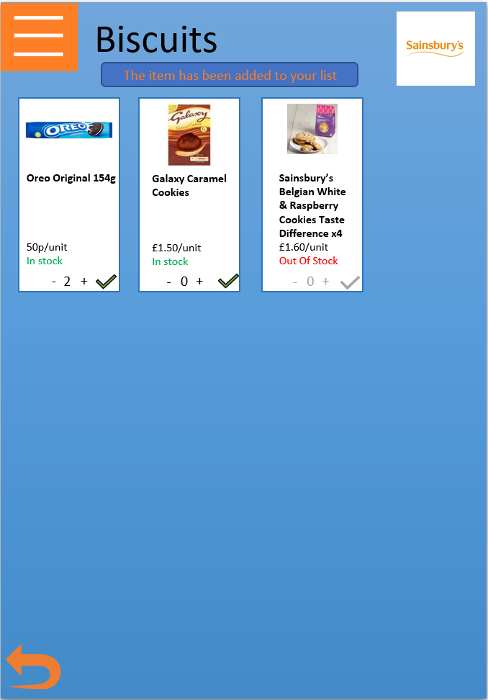

c

*Figure 10: There is one of the categories (Biscuits) in Sainsbury’s. It shows category on top, shop’s logo in the top right corner and products available (3 in every category). Each of the products contains the following (from top to bottom) (a): Image, name, price (as it is on the official website), whether it is in stock, and function to increase/decrease the amount required (b1, b2) and green tick on the right to confirm adding it to the shopping list. Once added, the confirmation message (c) will be displayed on the screen.*

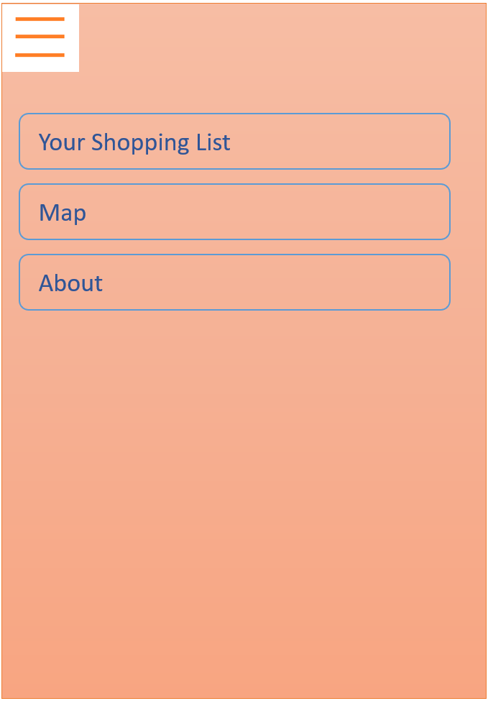 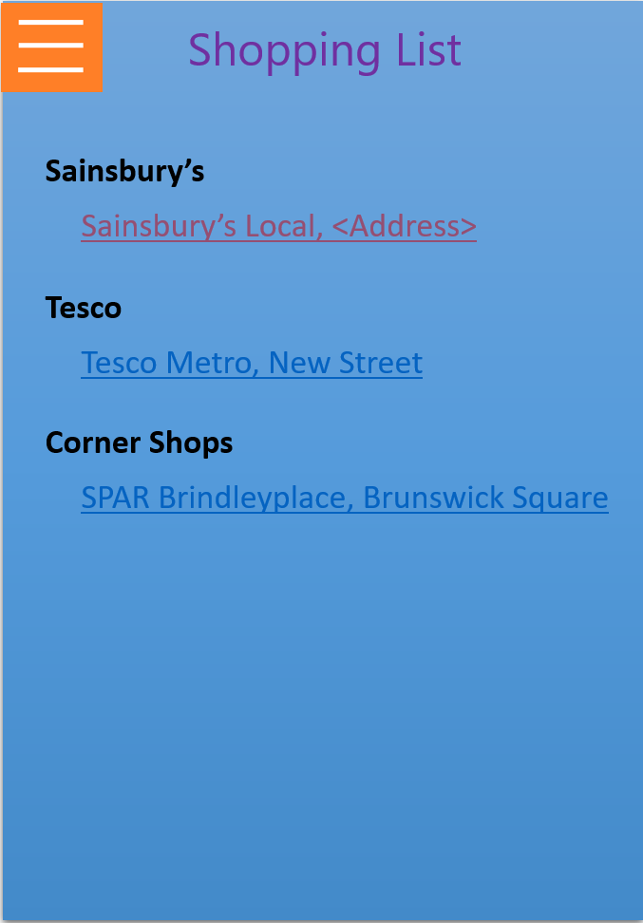

*Figure 11: The dropdown menu (left), available from maps sections and SPAR Shop page, dedicated to show users the functionality of shopping lists. “Map” takes you to the map, “About” takes you to the welcoming page. If “Your Shopping list is selected, it will show you shopping lists for shop you have created.*

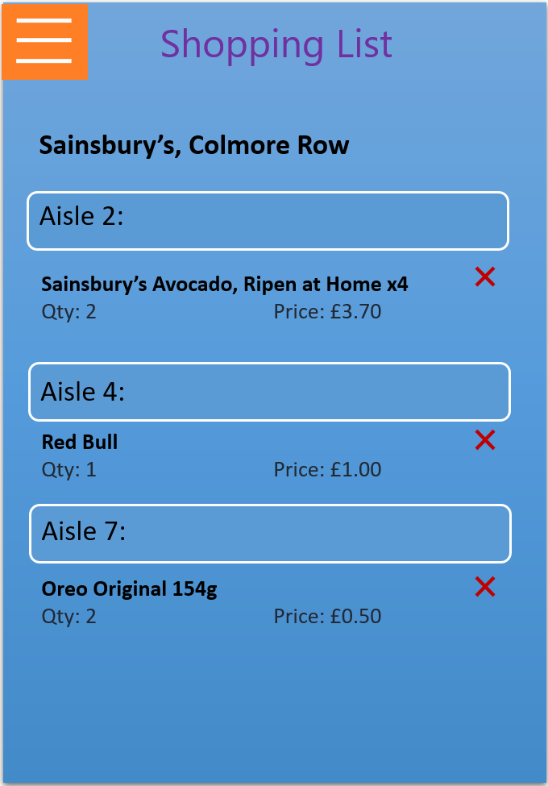 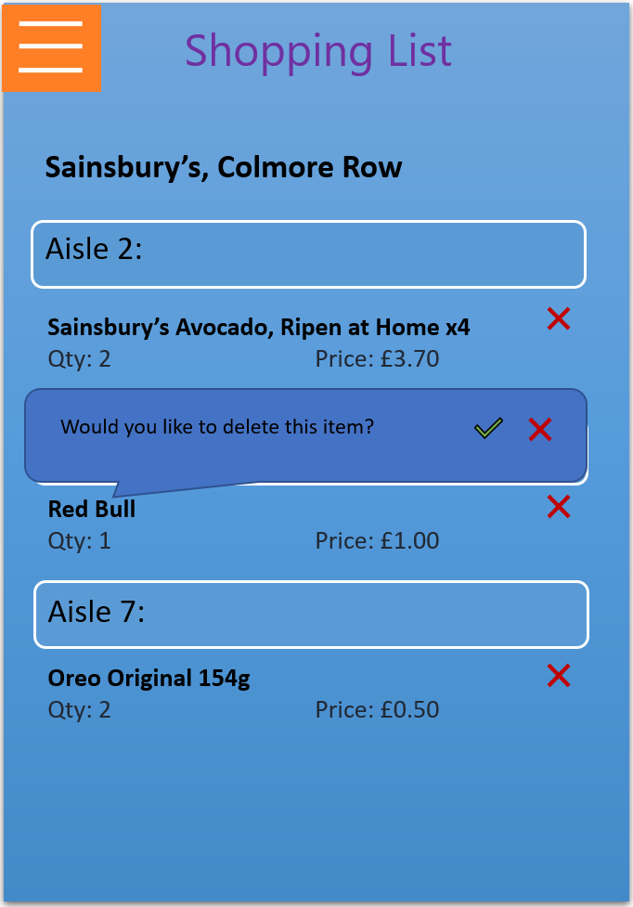 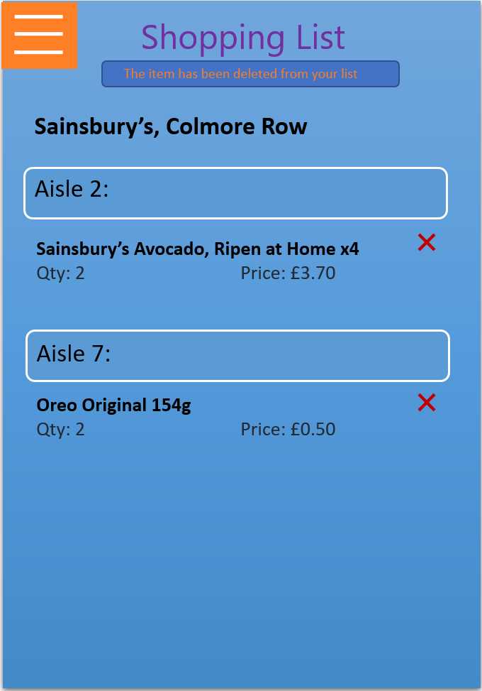

*Figure 12: Demonstration of the Shopping list (which sorts products by an aisle) with the only ability to delete the item from the shopping list. More functionality to be added.*

USER EVALUATION OF FIRST PROTOTYPE

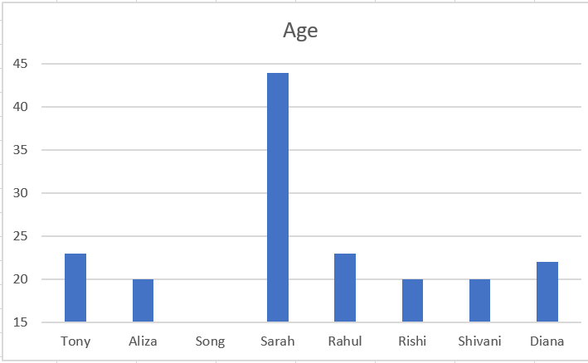

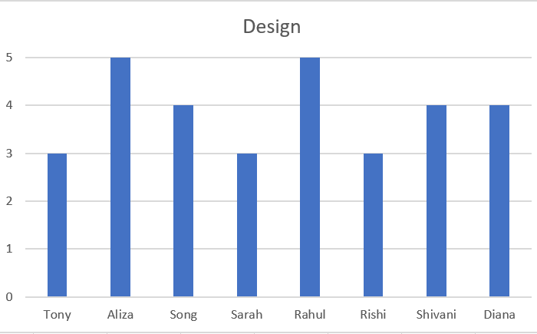 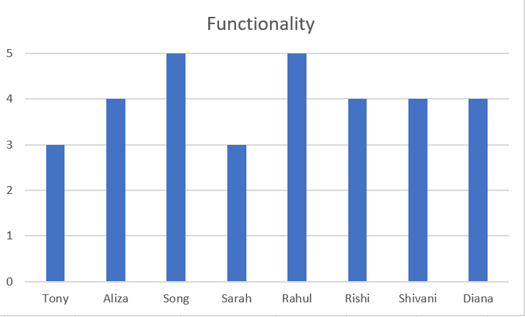

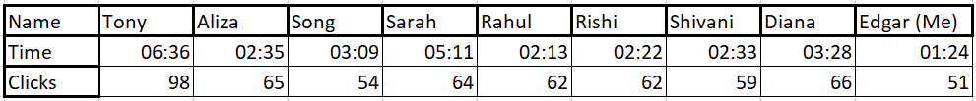

*Figure 13: 4 Charts here demonstrates: Age of participants (top), as well as their feedback (1-5) on design (middle left) and functionality (middle right). At the bottom you can see the number of clicks and time they did to reach the goals against mine (last column).*

My prototype was tested on 7 people, 6 students studying technology courses and 1 non-student user. As can be seen by the screenshots above, the amount of clicks they made fluctuates between 54 and 98, with me clicking 51 time. My prototype testers rated it quite positively, despite cut functionality and some design issues, with 3.875 for design and 4 for functionality (both in average). Users tested an app in 2 ways: some of them did everything straightaway, while some of them took their time completing it, exploring pages. PowerPoint is quite powerful to create mid-fi prototype, one of the tools of which is Visual Basic which would significantly help me with my prototype development (<http://www.pptfaq.com/HowToUseVBA.pdf>). And because I had no experience in it, I had to do it manually, which led to certain imperfections. One of them was to duplicate slides just for small changes (in Figure 9, b1 and b2 I was using 3-4 slides, for 0, 1, 2 (optional) and confirmation). Second problem was to keep certain details on the same page (like logos) and it can be seen on the same Figure, same logos tend to be placed in the slightly different locations.

Another thing was cut functionality. For my first prototype I have created 52 slides (2nd will have more), and in order to give it more functionality, I would have had to create 2 or 3 times more slides. Because of that users couldn’t access everything they wanted to.

REQUIREMENTS FOLLOWING USER EVALUATION OF FIRST PROTOTYPE

Starting with positive feedback (for more detailed feedback see Appendices), people liked the easiness of navigating around the app (despite mentioned cut functionality), the concepts of keeping shops in one app as well as having an aisle number for the shop in the shopping list.

From the things users would like to see improved there were loads of things needed to be added. Most criticized things were Logo (which would be better as an image, rather than sign with image), and ticks (2 people wrote about it in the report, but it can be seen that most of them do not see it). From the criticism I have decided to change background(?), do changes to font.

Last, but not least, the things people would like to see in the next prototype is seeing the total of their spendings as well as information about shops’ working times.

SECOND PROTOTYPE

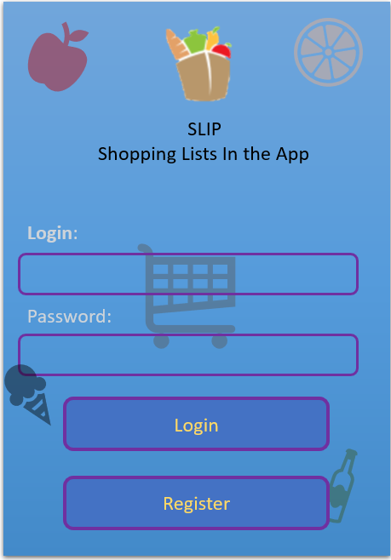 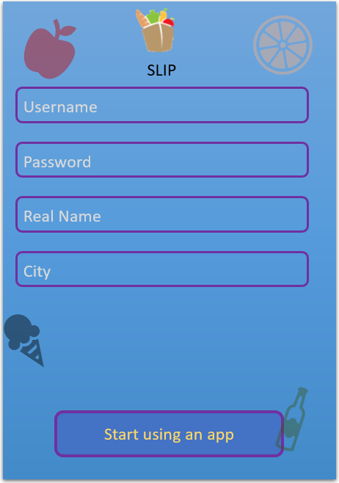

*Figure 14: In my second prototype I have changed the background by adding icons, which would more resemble the idea and concept of an app. I also have added an official apps’ icon and changed the name from “ShoppingApp” to “SLIP – Shopping Lists In the App” (Left). In addition, I have added a simple registration form for user.*

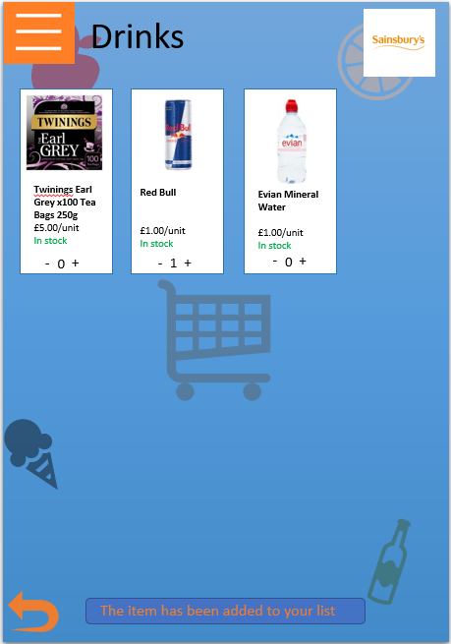 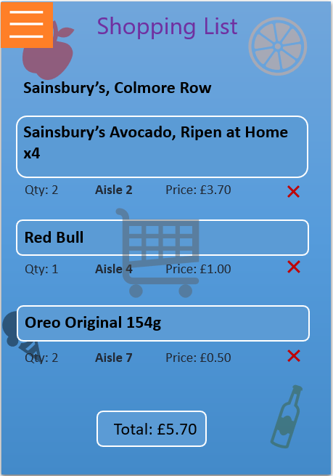

*Figure 15: Another changes, worth mentioning, are removal the ticks and putting the message after selecting at least one product. Also, the message of purchase is displayed on the bottom and is seen more (Left). On the right side, I have changed the layout, so the name of the products is bigger, and aisle displayed below at the middle. Also, the total price now is displayed at the bottom.*

USER EVALUATION

Users were very satisfied with an app in general. The average for the design and functionality increased to 4.625 and 4.5 respectively. They also liked new logo and name with rating in 4.375 in average. Users liked the removal of the tick as they were finding it extra. Some of the users as well found most of those details well and not in need for further approval.

REQUIREMENTS FOLLOWING USER EVALUATION OF SECOND PROTOTYPE

The main users’ request was to enable the functionality of the button at the top-left as it was not available everywhere.

DISCUSSION AND FUTURE WORK

At the end I was satisfied with the work completed. I was able to create and develop a shopping app which would make my life easier, even though there is more work needs to be done. The project like this requires a lot of data gathering, which is locations of the shops, the aisles for each specific product, and loads of products as well. Mainly functionality can be significantly improved, and some features can be added. I was satisfied with the design, as it is minimalistic, and user will understand the purpose of my app.

One of the things I have learnt is an importance of testing of an app, getting feedback and work on it. Based on the criticism I was able to improve my prototype and make it look better, as well as improvement of functionality.

As for things I would do in the future would be more to do with functionality, as currently both me and my testers are satisfied with it. Firstly, I would create more categories and create one more big supermarket chain (for example, Morrisons) and add more categories, possibly with subcategories (or leave it for the 4th prototype, as it requires significant collection of data). From minor things, I would add the ability to undo deletion from the shopping lists and, what most of the shopping apps do, cross it out from the shopping list (not delete it). Lastly, if it would come to hi-fi prototype, I would create the ability to set connection between accounts, so, for example, family members could update shopping list for the shopper, if necessary.

Thank you.

REFERENCES

Waygood, J. (n.d.). *8 Historic Artifacts that Cover 4,000 Years of Shopping History! - Listonic*. [online] Listonic. Available at: https://listonic.com/shopping-history/ [Accessed 23 Apr. 2019].

Best Products. (n.d.). *These 15 Grocery List Shopping Apps Make Meal Planning Super Simple*. [online] Available at: https://www.bestproducts.com/eats/food/g1505/grocery-shopping-list-apps/ [Accessed 23 Apr. 2019]

Smashing Magazine. (n.d.). *The Underestimated Power Of Color In Mobile App Design — Smashing Magazine*. [online] Available at: https://www.smashingmagazine.com/2017/01/underestimated-power-color-mobile-app-design/ [Accessed 23 Apr. 2019].

APPENDICES

